LAB EXERCISE 4

DEMONSTRATE HASH CRACKING USING JOHN THE RIPPER TOOL

AIM
To demonstrate password hash cracking using the John the Ripper tool on a Linux system in order to understand password vulnerabilities and the importance of strong password policies.

TOOLS / SOFTWARE REQUIRED
- Linux Operating System (Kali Linux / Ubuntu)
- John the Ripper (Jumbo version recommended)
- Terminal
- Sample password hash file
- Wordlist (rockyou.txt)

PROCEDURE

STEP 1: START LINUX SYSTEM
- Boot into Linux (Kali Linux recommended)
- Open the Terminal

STEP 2: VERIFY JOHN THE RIPPER INSTALLATION
Check version:
john
If not installed:
sudo apt update
sudo apt install john

STEP 3: CREATE A SAMPLE PASSWORD HASH
Create a test password hash (MD5 example):
echo -n "password123" | md5sum
Output:
482c811da5d5b4bc6d497ffa98491e38 -

STEP 4: CREATE HASH FILE
Create a file to store the hash:
nano hash.txt
Paste the hash:
482c811da5d5b4bc6d497ffa98491e38
Save and exit (CTRL + X, Y, ENTER).

STEP 5: BASIC HASH CRACKING USING JOHN
Run John the Ripper:
john hash.txt
John will automatically detect the hash type and attempt to crack it.

STEP 6: VIEW CRACKED PASSWORDS
john --show hash.txt
Output:
482c811da5d5b4bc6d497ffa98491e38:password123

STEP 7: DICTIONARY ATTACK USING WORDLIST
Use rockyou wordlist:
john --wordlist=/usr/share/wordlists/rockyou.txt hash.txt

STEP 8: SPECIFY HASH FORMAT (OPTIONAL)
For MD5:
john --format=raw-md5 hash.txt
For SHA-1:
john --format=raw-sha1 hash.txt

STEP 9: CRACKING LINUX PASSWORD HASHES (SHADOW FILE – DEMO)
Combine passwd and shadow files:
unshadow passwd.txt shadow.txt > crack.txt
Run John:
john crack.txt
View results:
john --show crack.txt

STEP 10: CHECK CRACKING STATUS
john --status

STEP 11: STOP THE PROCESS
Press:
CTRL + C

OUTPUT
Password hash successfully cracked
Original plaintext password recovered
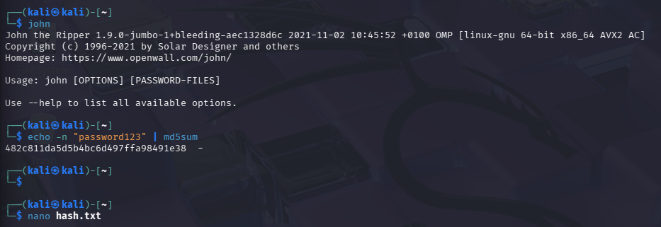
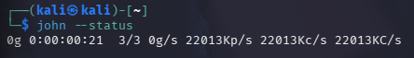

RESULT
Thus, hash cracking was successfully demonstrated using the John the Ripper tool on a Linux system.
This experiment highlights the risks of weak passwords and emphasizes the importance of strong hashing algorithms and password complexity.

